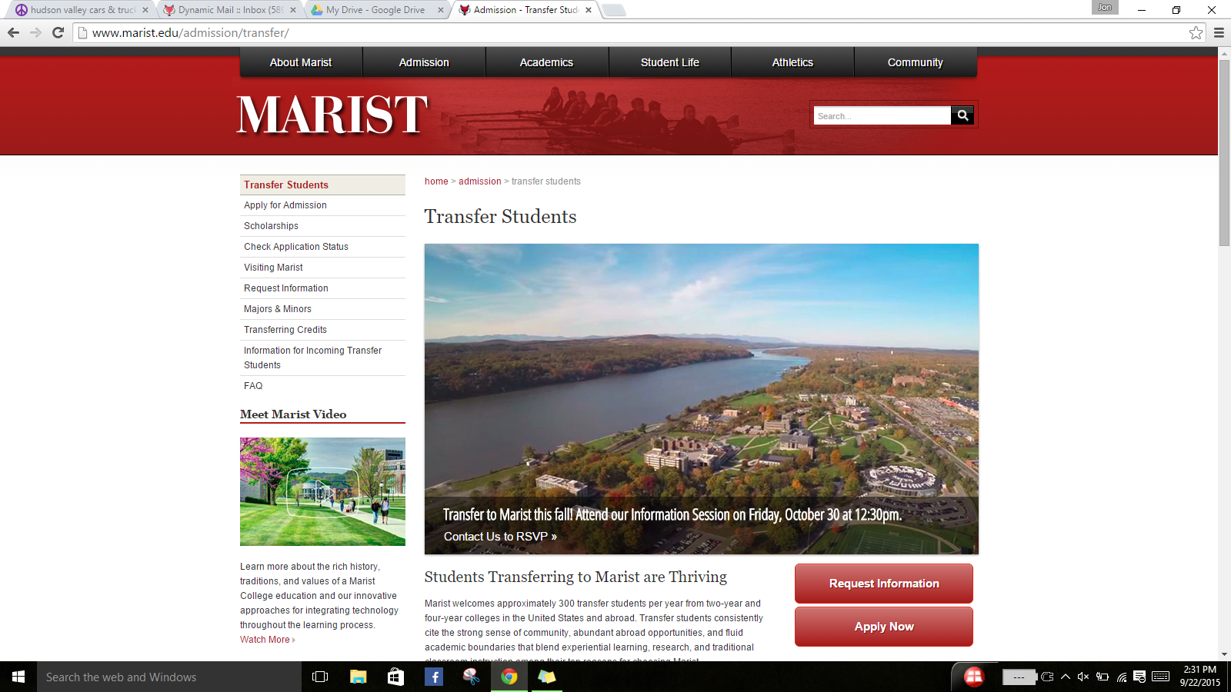

**Marist equivalent:**

**Submit**

**Admin Course Lookup:**

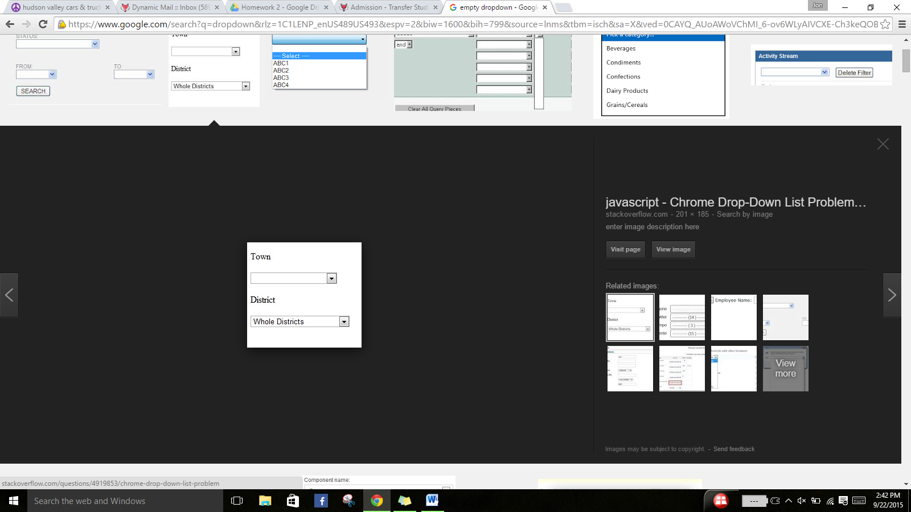





Subject: **Business**

Marist Class: **ACCT_204N**

Credits: **4**

College/University:

School of:

Class:

Dutchess Community…

Subject:

Class:

Business

**Course lookup**

Course Number:

ACC_201

